**Exp No 4 and 5: Practicing DDL Commands (Data Definition Language)**

* **Create table command**
* **Alter table command**
* **Truncate table command**
* **Drop table command**

create table students(Roll_id numeric(20) primary key,First_Name varchar(20),Last_Name varchar(20),Branch varchar(10));

desc students;

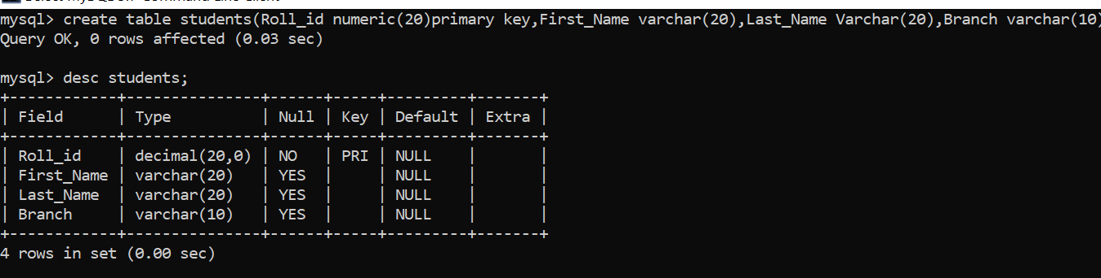

alter table students add Year_of_study varchar(20);



drop table students;

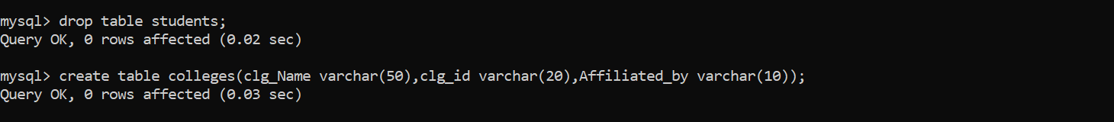

create table colleges(Clg_Name varchar(50),Clg_id varchar(20),Affiliated_by varchar(10));

truncate table colleges;

